The International College of Economics and Finance
Econometrics – 2018-2019.
Midterm exam 2019. March 28.

General instructions. Candidates should answer SIX of the following SEVEN questions: all 4 questions of the Section A and any 2 of the questions from Section B (questions 5-7). The weight of the Section A is 60% of the exam; three other questions from the Section B add 20% each. You are advised to divide your time accordingly. Structure your answers in accordance with the structure of the questions. When testing hypotheses state clearly null and alternative hypotheses provide critical value(s) used for the test, mentioning degrees of freedom, the significance level chosen for the test and the assumptions for the test to be valid.

SECTION A
(1 hour 50 minutes + 10 minutes for reading)
Answer ALL questions from this section (questions 1-4).
Each question in this section bears 15 marks

Question 1.
The following question concerns the effects of background characteristics on student’s performance in the AP Statistics Exam of the students of Californian school, measured in 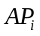 (Advanced Placement Statistics score in %). The AP Statistics Exam results are used for admission to some universities in the US.
, (1)
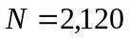, 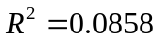.
The variable 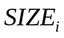 is the size of the student’s high school graduating class, in hundreds, 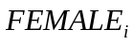 is a gender dummy variable (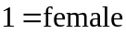, 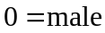), and 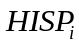 (Hispanic) is a language dummy variable (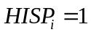 for students from Spanish speaking families, 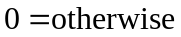). The standard errors are in parentheses.

(a) (5 marks) □ Give interpretation to the constant term of regression (1) and to the coefficients of 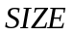 and 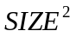. What is the economic rationale for including in the above regression? Using this equation, determine for a given gender and ethnic status, marginal effect of class size for class size of 200 and 50 students.
□ What the graduating class size would be at which the predicted AP Statistics scores are maximised.
□ Discuss any problem you may have in estimating the model if all females in your sample are Hispanic.

(b) (5 marks) □ Holding SIZE fixed, what is the estimated difference in AP Statistics score between non-Hispanic females and non-Hispanic males?
□ Is this difference statistically significant?
□ What is the estimated difference in AP Statistics score between Hispanic females and non-Hispanic females?

(c) (5 marks) □ How to estimate the significance of the difference in AP scores between Hispanic females and non-Hispanic females? What additional information would you need to obtain this estimation?

Question 2.
On the threshold of premiere of the last 8th season of famous American television series “Game of thrones” on April 2019 fans already make a bet on the destiny of remained characters. A student of ICEF decided to estimate their chances to survive. She found data on 1301 characters of Game of Thrones with such characteristics as the commitment to a noble house (NOBLE=1 if yes, and 0, if not), gender (GENDER=1 for female and 0 for male), the number of episodes in TV series a character participated (SCREENTIME), and the fact whether a character ever killed others (KILLING=1 if he/she did kill anyone during the series, 0 – otherwise). She runs different regressions with the following results (dependent variable ALIVE (ALIVE =1 if the character is still alive, ALIVE=0 if dead on the screen), (asymptotical) standard errors in parentheses): (Table 1)

 | (i)  (OLS) | (ii)  (LOGIT) | (iii) (LOGIT) | (iv)  (PROBIT)
NOBLE | 0.056  (0.025) | -0.340  (0.139) | 0.393  (0.181) | 0.162  (0.101)
GENDER | 0.320  (0.036) | 2.088  (0.198) | 1.490  (0.211) | 0.883  (0.124)
KILLING | -0.368  (0.024) | - | -2.426  (0.195) | -1.350  (0.101)
SCREENTIME | 0.010  (0.0018) | - | 0.067  (0.0118) | 0.038  (0.0066)
Constant | 0.383  (0.017) | -1.016  (0.082) | -0.570  (0.094) | -0.335  (0.057)
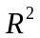 | 0.263
McFadden |  | 0.091 | 0.236 | 0.236
RSS | 197.95 | 238.90 | 197.28 | 197.83
LogL | -621.23 | -720.35 | -599.73 | -599.59
Hint: in probit model the standard normal probability function is used 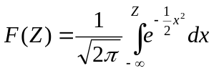.
There is also information beneath on some of beloved characters of our student: (Table 2)
 | Alive | Gender | Noble | Killing | Screentime
Sansa Stark | 1 | 1 | 1 | 1 | 54
Tyrion Lannister | 1 | 0 | 1 | 1 | 61
Sandor 'The Hound' Clegane | 1 | 0 | 1 | 1 | 33

(a) [5 marks] □ What is the chance to survive in the next season for Sandor “The Hound” according to regressions (i) and (iii)? The results are close to each other, does it mean that two methods are equivalent and both models can be equally trusted?
□ Using regression (iii) help the student to evaluate the marginal effect of the number of episodes Sandor “The Hound” appeared. Compare it with the corresponding result for regression (i). Why they are different?

(b) [5 marks] □ According to regression (iv) what is the chance to survive for Sansa Stark – one of the main female characters of Game of Thrones?
□ Evaluate the marginal effect of gender for this character and compare your result with the maximum possible effect of gender using model (iv).
□ Based on the information in table 2, explain why the chances to survive for Tyrion Lannister estimated by the same model (iv), are lower than those of Sansa Stark.

(с) [5 marks] □ Evaluate whether two variables KILLING and SCREENTIME in regression (iii) are significant taken together? Explain your work. What conclusions can you draw on the quality of regressions (ii) and (iii)?
□ For regression (ii) evaluate whether the coefficient of variable NOBLE is significant?
□ For regression (ii) evaluate whether two variables NOBLE and GENDER are significant taken together?
Question 3
Using annual data for the period from 1970 to 2003 (34 observations), a student investigates the relationship between GDP of Australia and GDP of Fiji (small island country near Australia so their economies can be closely connected). Regressing logarithm of Fiji GDP 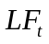 on the logarithm of Australian GDP 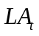 she obtains the following results (here and further standard errors in parenthesis)
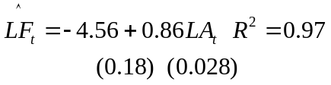 (1)
Suspecting that this regression may be spurious she investigates time series and for stationarity, obtaining the following Dickey-Fuller equations for them, as well as for their first differences 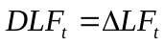 and 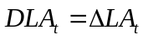:
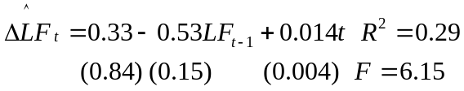 (2a) 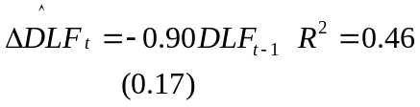 (2b)
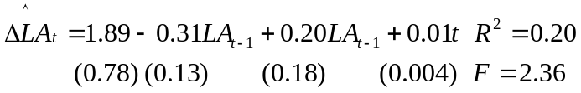 (3a), 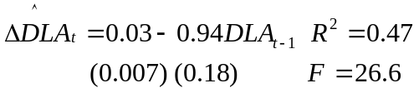, (3b)

(a) (5 marks) □ Briefly explain the theory behind the estimation of the Dickey-Fuller equations (2a, 3a).
□ Use (Augmented) Dickey-Fuller t-test to prove or disprove the student’s suspicions. Comment the results.
□ Determine whether the differences 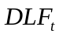 and 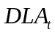 are stationary, based on the same test for equations (2b, 3b). What is their economic meaning? Show mathematically that your interpretation is correct.

(b) The results of the ADF t-test for (eq.2a) are questionable, so it is better to use additional tests for nonstationarity.
□ Use ADF 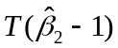 test for equations (2a) and (2b) and comment the results.
□ Use ADF F-test for equations (3a) and (3b). What additional information gives this test in (3a) and (3b)? Why applying ADF F-test to equation (2b) gives no additional information?
□ Compare three ADF tests, in relation to the results in (a) and (b)?

(c) (5 marks) The residuals 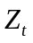 from equation (1) turned out to be stationary so the student decided to use this equation as cointegration relationship.
□ Describe how to do it deriving error correction model in the context of the problem under consideration, corresponding to the estimated equation
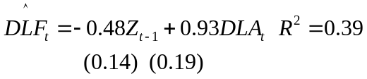 (4)
□ Interpret the coefficients of the model (4).
□ Explain what are advantages (and possible disadvantages) of the error correction specification comparing to the model (1) and the difference model based only on the differences 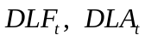.

Question 4.
A student took the data for 26 OECD countries, average for 2 time periods, on E (average annual percentage rate of growth of employment for country i during time period t) and G (average annual percentage rate of growth of GDP for country i during time period t). The initial model for the panel data under consideration is
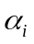 here is unobserved heterogeneity term, 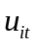 is disturbance term, satisfying usual assumptions.
The original data for the situation under consideration can be represented by two tables (26 observations of E and corresponding 26 observations of G for two years)
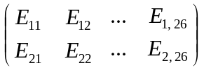 and 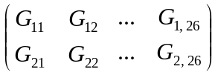
Having the panel of 52 observations, he decided to run the Fixed Effect regressions: LSDV, Within Groups and First Differences.

(a) (5 marks) □ Briefly describing each method in the context of the problem under consideration, explain why all three methods lead to the loss of the same number of degrees of freedom. What is this number?

(b) (5 marks) In general coefficient estimates 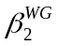 in the Within Groups and 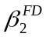 in the First Differences regressions are different. But the panel data under consideration has a special structure.
□ Show that in our case these estimates are the same: 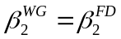.
□ And what about 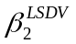? (no proof required)
□ Show that for the model under consideration 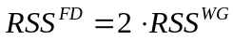.

(c) (5 marks) □ Based on previous results, find the ratio of the standard errors of coefficient estimates in two regressions 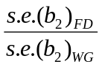.

SECTION В
(1 hour 10 minutes + 10 minutes for reading)
Answer TWO questions from this section (questions 5-7).
Each answered question in this section bears 20 marks.

Question 5. The financial analyst considers monthly data on the short-term interest rate (the three month Treasury Bill rate) and on the AAA corporate bond yield in the USA. The data run from January 1950 to December 1999.
Let DUS3MT denote the changes in three-month Treasury Bill rate, and DAAA denote the changes in AAA bond rate. We consider the following results (with the standard errors given in parentheses)
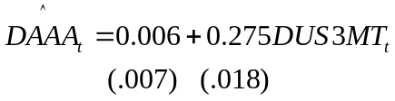, 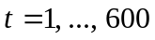, (1)
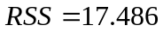; 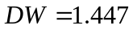,
where RSS is the residual sum of squares and DW is the Durbin—Watson test. A researcher interpreting the residuals suggests that the errors show a positive correlation over time.

(a) (5 marks) □ Use the results above to test for the presence of first-order positive autocorrelation. Briefly describe the Durbin-Watson test: clearly specify the null and alternative hypothesis, test statistic, assumptions underlying the test, and the acceptance/rejection rule.
□ Show that 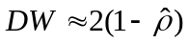 where 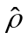 is autocorrelation coefficient.
□ What are the consequences of this correlation for the above regression results?

(b) (5 marks) In an attempt to remove the autocorrelation you consider the following specification
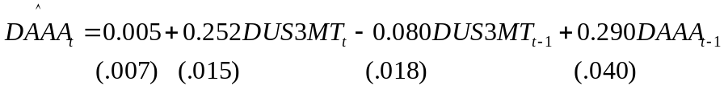, (2)
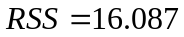; 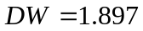.
□ Comment on the following statement ‘The Durbin—Watson statistic is closer to 2, indicating that we have successfully removed the autocorrelation’. If you disagree with this statement, explain why, and suggest what test can be done based on the available data.
□ What are the reasons to consider the second model as an improved version of the first?
□ Can you estimate long term effect of 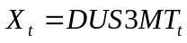 on 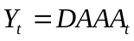? Compare it with the short term effect.

(c) (5 marks) □ Discuss the Common Factor Test as a model specification suitable for this model.
□ Derive Common Test specification from the ADL(1,1) model, corresponding to the equation (2).
□ What extra information do you need to conduct this test? What assumptions are needed for this?

(d) (5 marks) □ After estimating unrestricted model corresponding to Common Test specification the value of 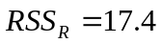 was obtained. Do the common factor test, and make the conclusion. What specificaion should be chosen on the base of the test, what are interpretations of its parameters?
□ It was found that the value of 17.4 was mistakenly obtained by rounding off the exact number 17.361. How this changes your conclusion and the interpretation of some parameters of the model?

Question 6.
A student of ICEF considers for her graduation thesis the hedonic price function for houses. The hedonic price refers to the implicit price of a house given certain attributes (e.g., the number of bedrooms). The data contains the sale price of 546 houses sold in the summer of 2017 in the Moscow region (in thousands of rubles) along with their important features. The following characteristics are available: the lot size of the property in square meters (lotsize), the numbers of bedrooms (bedrooms), the number of full bathrooms (bathrooms), and a dummy indicating the presence of air-conditioning (airco).
Consider the following ordinary least squares results
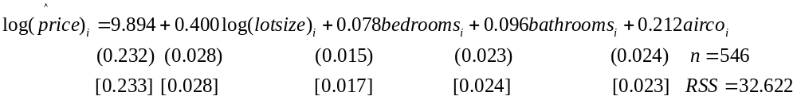 (1)
The usual standard errors are in parentheses, the heteroskedasticity robust standard errors are in square brackets, and RSS measures the residual sum of squares.

(a) (5 marks) □ Interpret the parameter estimates on 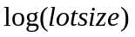, 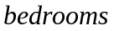 and 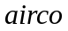 not taking into account that is a dummy variable.
□ How the interpretation of the coefficient of will change if we take into account that is a dummy variable? Explain.

(b) (5 marks) □ The student combines two variables and 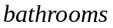 into one
and runs the second regression
, (2)
This equation is a restricted version of equation (1). Test the restriction (indicate the restriction). Which regression would you choose for further analysis?

□ A friend of the student living in the United States became interested in buying a house in the Moscow region, and asked the student to convert the equations into more familiar to him unit of measurement of the area of the house in square feet. Help the student get a new equation (intercept and coefficients) without re-calculating the regression equations. Note: the conversion (approximate) 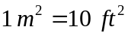.

(с) (5 marks) □ The student suspects the presence of heteroscedasticity in the data. She noticed that the variance of 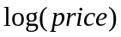 is increasing with . To test for heteroscedasticity she orders the 546 observations by the magnitude. Then she runs the same regression (1) using 212 observations with the smallest values of , obtaining 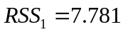, and then runs the same regression for 90 observations with the largest values of , obtaining 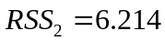 (an unequal number of observations was taken due to the fact that number of lots with high prices turned out to be significantly less). Help the student to run the appropriate test and to make the conclusion.

□ Student’s friend advised her to use White test instead. She runs test for restricted regression (2) obtaining for the auxiliary equation of the White test the value of 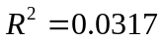. Help the student to complete the test briefly explaining her the logic of this test, indicating distribution, degrees of freedom, critical values and final conclusion.

(d) (5 marks) Consider simple linear regression model 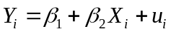, 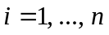.
□ Under assumptions 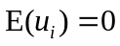, 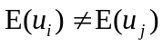 for some 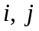, 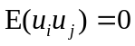 derive the variance of the regression coefficient 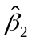, and indicate the formula for the standard error of regression coefficient (heteroscedasticity-consistent standard error with White correction).

□ What are the main properties of standard errors, obtained by this method? Comment the differences between two types of standard errors in equation (1)?

Question 7.
The following model jointly determines monthly child support payments (support) and monthly visitation rights (visits) for divorced couples with children:

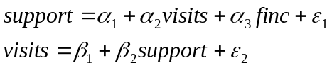. (1)

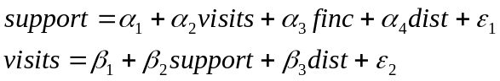, (2)

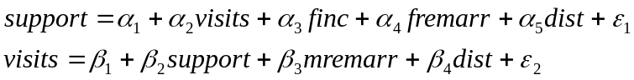 (3)

We assume that children live with their mothers, so that fathers pay child support. Thus, in the system of equation (1) the first equation is the father’s ‘reaction function’: it describes the amount of child support paid for any given level of visitation rights and the exogenous variable finc (father’s income). Similarly the second equation is the mother’s reaction function: it describes visitation rights for a given amount of child support.
The system of equation (2) includes also variable dist (miles currently between the mother and father’s residence).
In the system of equations (3) two additional dummy variables are added: fremarr (binary indicator if father remarried), and; mremarr is a binary indicator for whether the woman is remarried.
The variables finc, dist, fremarr and mremarr are considered as exogenous. Disturbance terms of all equations are assumed to be uncorrelated with exogenous variables and with each other.

(a) (5 marks) □ Examine the identification of each structural equation in the systems (1)-(2)-(3) using two methods: instrumental variables approach, and order condition, each of these methods should be used at least once.

(b) (5 marks) □ Derive Reduced Form model for (1).
□ Show that OLS estimator of parameter 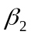 in second equation of (1) is inconsistent. Find its large sample bias.

(c) (5 marks) □ Using Reduced Form model obtain ILS estimator of .
□ Prove that it is consistent.

(d) (5 marks) □ What methods provide a consistent estimate of the coefficient in the second equation of the system (2)?
□ What methods provide a consistent estimate of the coefficient in the second equation of the system (3). Give details.

